Talking to the police

A guide to explain your rights when talking to the police.

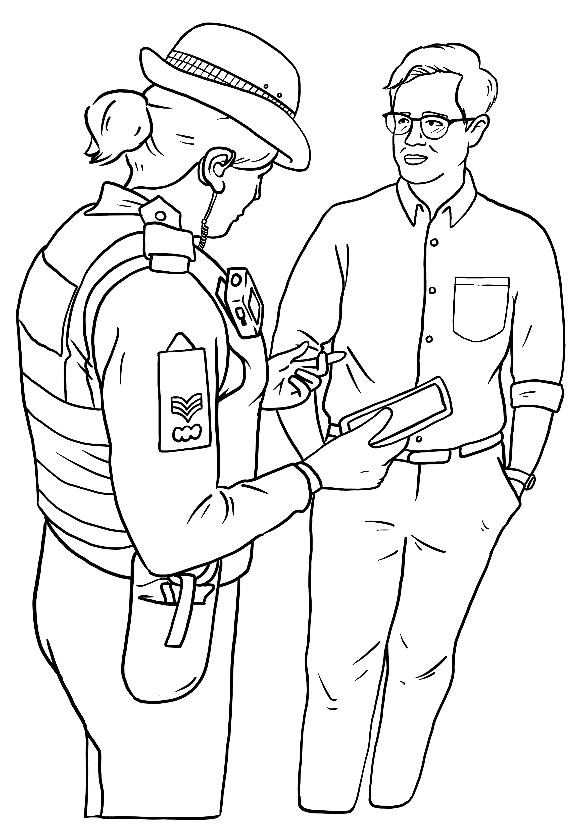

Brought to you by [Liberty](https://www.libertyhumanrights.org.uk/) and [Include.org](https://include.org/about-include/). Images by [Change People](https://www.google.com/url?sa=t&rct=j&q=&esrc=s&source=web&cd=&cad=rja&uact=8&ved=2ahUKEwjf9t3Pr_6FAxUUZEEAHRR9A6YQFnoECAgQAQ&url=https%3A%2F%2Fwww.changepeople.org%2F&usg=AOvVaw3QPkEC1blEHCleo3QM3DeY&opi=89978449).

This guide explains your rights when talking to the police.

Big words are in **bold writing**. There is a list of big words at the end. It explains what these words mean.

|  |  |
| --- | --- |
| **Section 1: Can the police ask me questions on the street?** | |
| Woman asking a question | Anyone can ask you a question.  The police can ask you questions. |
| Police officer with clipboard asks woman question | If a police officer asks you questions, that does not mean you have done anything wrong. |
| Woman asks police officer for the officer's ID. | You should always ask to see a police officers’ ID.  ID shows you who the officer is. |

|  |  |
| --- | --- |
| **Section 2: do I always have to answer police questions?** | |
| Woman shrugging, has a choice | No, you do not always have to answer police questions.  You have a choice. |
| Woman in hijab speaking to police officer | You can choose to talk. |
| Woman in hijab not speaking to police officer | You can choose to not talk. |

|  |  |
| --- | --- |
| **Section 3: why would the police want to speak to me?** | |
| Police officer asking woman in hijab a question | The police may want to speak to you for different reasons. |
| Police officer asking if a crying woman in hijab needs help. | Police may want to speak to you because you need help |
| Police officer visiting someone's house | Police may want to speak to you because they think you did something wrong. |
| Police officer asking woman in hijab about a crime the woman saw | Police may want to speak to you because they think you saw a crime. |
| Person thinking about their choice to speak or not to speak to the police | You have a choice to talk to the police or not. |

|  |  |
| --- | --- |
| **Section 4: Seeing (witnessing) a crime and answering questions** | |
| Child seeing a man pull a woman's hair | A **witness** is someone who **sees** a crime happening.  A crime is when someone breaks the law.  If you see a crime, you are a **witness**. |
| Man telling police officer about seeing a man punch someone | Sometimes the police want to ask witnesses about what they saw.  They will ask to speak to the witness.  This is called a **witness** **interview**. |
| Person thinking about their choice to speak or not to speak to the police | You have a choice to talk to the police or not. |

|  |  |
| --- | --- |
| **Section 5: witness interviews at the police station** | |
| Police taking a witness to the police station | The police can ask to take you to a police station to do the **witness interview**.  A **witness interview** is when the police ask you questions because you saw a crime. |
| Police officer interviewing a witness, tells the witness the officer's name is PC Blogs. | If you go to the police station, the police can **interview** you.  This is when the police ask you questions about what you have seen. |
| A person thinking about their choice to go to the police station or not for an witness interview | You can choose.  You can go to the police station if you want to.  You do not have to go to the police station. |

|  |  |
| --- | --- |
| **Section 6: Being a suspect and answering questions** | |
| A police officer speaking to someone suspected of hurting another person | A **suspect** is someone who the police think has broken the law. |
| 2 police officers arresting someone and taking the person away | If you are a suspect, you don’t have to talk to the police.  Different things can happen if you are a suspect.  What happens depends on what the police believe you have done. |

|  |  |
| --- | --- |
| **Section 7: Stop and search and answering questions** | |
| 2 police officers stopping 2 young boys in order to search them. | Sometimes the police can stop you to see what you have.  Police can stop you if they think you have something that can hurt someone (**dangerous**) or something against the law (**illegal**). |
| A police officer searching someone's coat pockets | Stopping you to see what you have is called **stop and search**.  The police can search you.  They will check your clothes to see what you have. |
| A woman wearing a hijab not talking to a police officer. | You have to stay while the police search you, but you don’t have to say anything. |

|  |  |
| --- | --- |
| **Section 8: Antisocial behaviour and answering questions** | |
| A woman in a hijab is upset because of load music, rubbish on the floor, and graffiti on the wall.  3 people behaving in an anti-social way: drinking, smoking, littering and doing graffiti | Behaving in an **antisocial** way means you are making someone else feel very worried or scared. |
| A police officer asking for someone's name and address | The police can ask your name and address if they think you are behaving in an antisocial way. |
| A young boy tells 2 police officers his name and address. | You **do** have to tell the police your name and address if the police believe you are acting in an antisocial way. |
| A young boy refusing to tell 2 police officers his name and address  Someone in handcuffs | It’s a crime if you behave in an antisocial way **and** you don’t tell the police your name and address. |
| 2 young boys telling 2 police officers their name and address, and thinking "that's it" because that's all they have to say. | You only have to tell the police your name and address.  You don’t have to say anything else. |

|  |  |
| --- | --- |
| **Section 9: Being arrested and answering questions** | |
| 2 police officers arresting someone and taking the person away | **Arrest** is when the police take you to the police station.  The police can **arrest** you if they believe you have broken the law. |
| A police officer waiting by a police car with an open door | If you are **arrested**, you have no choice.  You must go with the police. |
| A police officer saying "you and under arrest for.." | The police must tell you that they are arresting you.  The police must say **why** they are arresting you. |
| Police taking a suspect to the police station | If you are arrested, the police will take you to the **police station**. |
| A woman wearing a hijab not speaking to a police officer. | You do not have to talk to the police on the way to the police station. |

|  |  |
| --- | --- |
| **Section 10: Caution on arrest** | |
| A police officer telling someone about their rights | If the police think you have broken the law, they must tell you that you have **rights**.  Rights are things you must be given. |
| A police officer reading a person a "caution" which tells them about their rights | Telling you your rights after you’re arrested is called reading you **a caution**. |
| A person not speaking to a police officer | It means you don’t have to say anything about what the police think you have done. |

|  |  |
| --- | --- |
| **Section 11: interview under caution** | |
| Police officer interviewing a suspect, tells the suspect the officer's name is PC Blogs. | At the police station, the police will ask you about what you did.  This is called an **interview under caution**. |
| A police officer reading a person a "caution" which tells them about their rights | The police must read the caution to you first. The police must tell you your rights.  Then they can interview you. |
| Police officer interviewing a suspect, the suspect says nothing. | You do not have to say anything in the interview under caution. |

|  |  |
| --- | --- |
| **Section 12: your rights if you are arrested** | |
| A solicitor wearing a hijab carrying a briefcase | You have the right to speak a **solicitor** before the interview if you are arrested.  A solicitor tells you about your rights. |
| A solicitor wearing a hijab tells a person about their rights under the law. | If you are arrested, it’s good to speak to a solicitor before you speak to the police. |
| A person reading their rights at the police station | You have lots of other rights at a police station.  You can read more [in Easy read on this website](https://www.derbyshire-pcc.gov.uk/Document-Library/Taking-Part/Volunteer-Schemes/ICV-Forms/Easy-Read-Rights-and-Entitlements-2014.pdf). |

**List of words**

**Antisocial:** acting in a very unkind way, making people feel scared and unsafe

**Arrest**: if police stop you and take you to a police station because they think you’ve done a crime.

**Behaviour:** the way a person acts

**Caution**: when the police tell you what rights you have if you are arrested

**Crime**: when we do something wrong and break the law

**Dangerous**: something that can hurt someone

**ID**: tells you who someone is.

**Illegal**: something that is against the law and not allowed.

**Interview**: when someone asks you a lot of questions to find out something

**Interview under caution**: when you are arrested and the police ask you a lot of questions after telling you your rights

**Law**: rules that tell us what we can and can’t do. It helps everyone live together in a society.

**Police station**: where the police officers work and speak to members of the public.

**Right**: a right something you have because of a law. It means that other people have to do something for you or give you something.

**Solicitor**: a lawyer who tells you about your rights

**Stop and search**: when the police stop you because they think you broke the law. They check to see what you’re carrying.

**Suspect**: someone the police think has broken the law

**Witness**: someone who sees a crime happen

Liberty Advice and Information

March 2024

Thank you Include.org champions!

You helped make this guide.

Liberty is very grateful for your help!

Do you have questions about this guide?

Contact [Liberty’s Advice and Information team](https://www.libertyhumanrights.org.uk/advice-and-information/contact-us/).